**Backend Design:**

**Tool Used:**

**PlantUML for Backend Models**

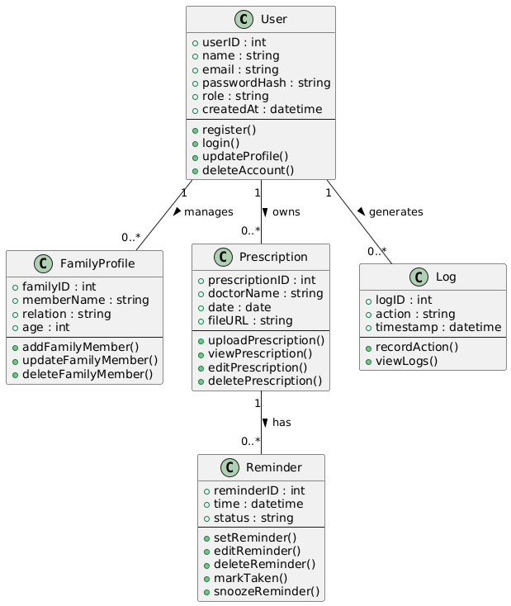

**Eraser for Database Design**

